**Here’s a more detailed Information Architecture section for your project:**

Information Architecture

**1. Sitemap:**

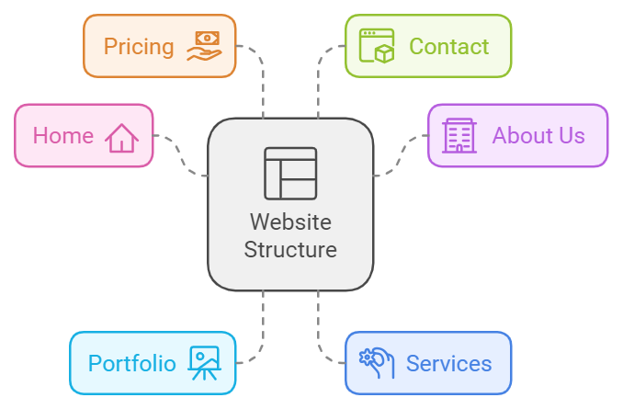

—--------------------------------------------------------------------------------------------------------------

**Here's a user guide for the website, detailing how to navigate and use it effectively:**

**User Guide: How to Use the Portfolio Website**

**Introduction**

Welcome to our Portfolio Website, designed to showcase the expertise of four professionals in the fields of chemistry/microbiology, legal consulting, web design, and professional transitions. This user guide will help you understand how to navigate through the website, explore our services, view portfolio projects, and contact us for more information.

**1. Home Page**

When you land on the **Home Page**, you’ll see an introduction to our platform and an overview of the services offered. This page gives a quick summary of what we do, so you can get a clear idea of our areas of expertise right from the start. The navigation menu at the top of the page allows you to quickly move between the different sections of the website.

**2. About Us**

**The About Us page provides detailed profiles of the four professionals who contribute to this platform:**

- **Chemistry/Microbiology Specialist:** Learn about our expert in applied chemistry and industrial microbiology, who offers consulting and scientific content creation.

**- Legal Consultant:** Get to know the legal professional who provides consulting, legal translations, and multilingual legal support.

**- Web Designer:** Find out about the web designer who specializes in building responsive and dynamic websites for clients across industries.

**- Professional Transition Coach:** Understand how our career coach helps individuals through job transitions and career development.

**Each profile gives you a deeper understanding of the team members and their unique skills, offering insight into how their services can benefit you.**

**3. Portfolio**

**In the Portfolio section, you can explore the various projects we’ve worked on. This section is divided into three main categories:**

**- Web Design:** Browse examples of websites designed by our team, which emphasize modern, responsive, and user-friendly designs. Each project includes details about the goals, technologies used, and design process.

- **ChemBio Coder:** This part showcases the chemistry/microbiology-based projects, featuring web designs and content platforms related to scientific research and education.

**- Lawyer/Translation:** Here, you’ll find examples of legal projects, including document translations and multilingual consulting, tailored to international clients.

**Each project includes a description of the problem we solved, the services provided, and screenshots of the final product. You’ll also find the specific contributions made by each professional to give you a clear idea of how our services integrate across fields.**

**4. Services**

The Services page provides detailed descriptions of the services offered across the four fields:

**- Chemistry/Microbiology:** Offering scientific consulting, content creation, and technical writing services for industrial and educational purposes.

**- Legal Consulting:** Providing corporate legal advice, document translations, and general consulting for businesses and individuals.

**- Web Design:** Specializing in the creation of modern, responsive websites that are tailored to the needs of businesses, professionals, and educators.

**- Professional Transitions:** Coaching services aimed at helping individuals navigate career changes, enhance their skills, and plan for future growth.

You can click on each service category to get more information, including the types of projects we work on and the benefits of each service.

**5. Pricing**

**In the Pricing section**, you will find details about our flexible pricing structure. Depending on the complexity and scope of the project, **prices range from EGP100 to EGP600.** Here’s a breakdown of our pricing:

**- Basic Packages (EGP100-EGP200):** Includes simple consultations, entry-level website designs, or basic legal document translations.

**- Advanced Packages (EGP300-EGP500):** More comprehensive services, such as custom website development, detailed scientific reports, or advanced legal consultations.

- **Premium Packages (EGP500-EGP600):** Tailored solutions, such as complex web development, comprehensive legal cases, or full-scale scientific consulting projects.

The pricing page helps clients understand the costs associated with each service and decide on the package that best suits their needs.

**6. Contact**

Finally, **the Contact page** provides easy access to our team. You can fill out a simple form to send inquiries or request more information. You’ll also find contact details for each professional, so you can directly reach out to the expert most relevant to your needs.

### **Slider Functionality: Portfolio Navigation**

In the Portfolio section of the website, you will find a dynamic slider that showcases featured projects from each of the four service areas: Web Design, ChemBio Coder, Legal Consulting, and Professional Transitions. The slider allows users to visually browse through different portfolio highlights.

Each slide represents a professional's portfolio, showcasing their unique contributions and expertise. Here's how the slider navigation works:

#### **How It Works:**

1. **Browse Projects:**
   * Each slide in the portfolio slider presents a brief overview of one of the professional’s projects, featuring a representative image or screenshot and a short description.
   * You can swipe or use the navigation arrows to move between slides for Web Design, ChemBio Coder, Legal Consulting, and Professional Transitions**.**
2. **"Go to Page" Button:**
   * On each slide, there is a "Go to Page" button that allows users to explore the full project in detail.
   * Clicking this button will take you to the specific portfolio page for the highlighted project, where you can learn more about the project’s idea, services, and unique offerings.

#### **What Happens When You Click "Go to Page":**

* **Web Design Portfolio:**
  + On this page, you’ll find more information about the various web design projects we've completed. The focus will be on how our designs are tailored to meet the client’s specific needs, with an emphasis on responsiveness, modern design techniques, and user-friendly interfaces.
  + You will also see case studies showing how we incorporated branding and user experience considerations into each design.
* **ChemBio Coder Portfolio:**
  + Here, you will explore our projects focused on chemistry and microbiology content. This page will showcase platforms designed for scientific education, research, and consulting services.
  + The uniqueness of these services lies in our ability to simplify complex scientific concepts and present them through engaging digital platforms that cater to both professionals and learners in the field.
* **Legal Consulting Portfolio:**
  + This section will highlight our legal projects, including document translations, legal case studies, and consulting services. The focus here is on how we handle complex legal issues with expertise, while also offering multilingual solutions to international clients.
  + You’ll learn about the tailored approach we take with each client, ensuring that legal advice is both practical and adapted to the specific industry or country.
* **Professional Transitions Portfolio:**
  + On this page, you’ll find examples of our coaching services, detailing how we help individuals navigate through major career transitions. Our services are designed to offer personalized guidance, whether for a career change, skill development, or workplace adjustments.
  + The unique value here lies in our ability to provide custom coaching tailored to each client’s professional goals, ensuring a smooth and successful transition.

#### **Why This Matters:**

The Go to Page functionality is designed to enhance user engagement by allowing them to delve deeper into each professional’s portfolio. Each portfolio section not only highlights the work done but also explains the unique approach and value proposition of the services we provide.

The seamless transition from the slider to the detailed portfolio pages ensures that users can easily navigate through various service offerings and explore the full range of projects in a structured, accessible way.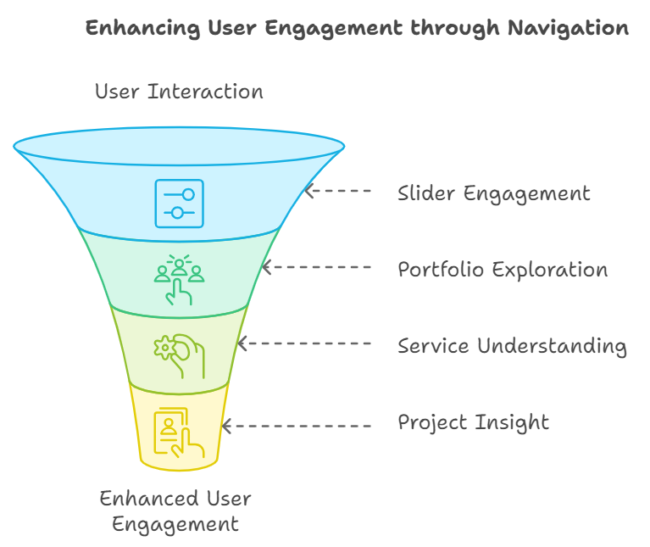

**our portfolio:**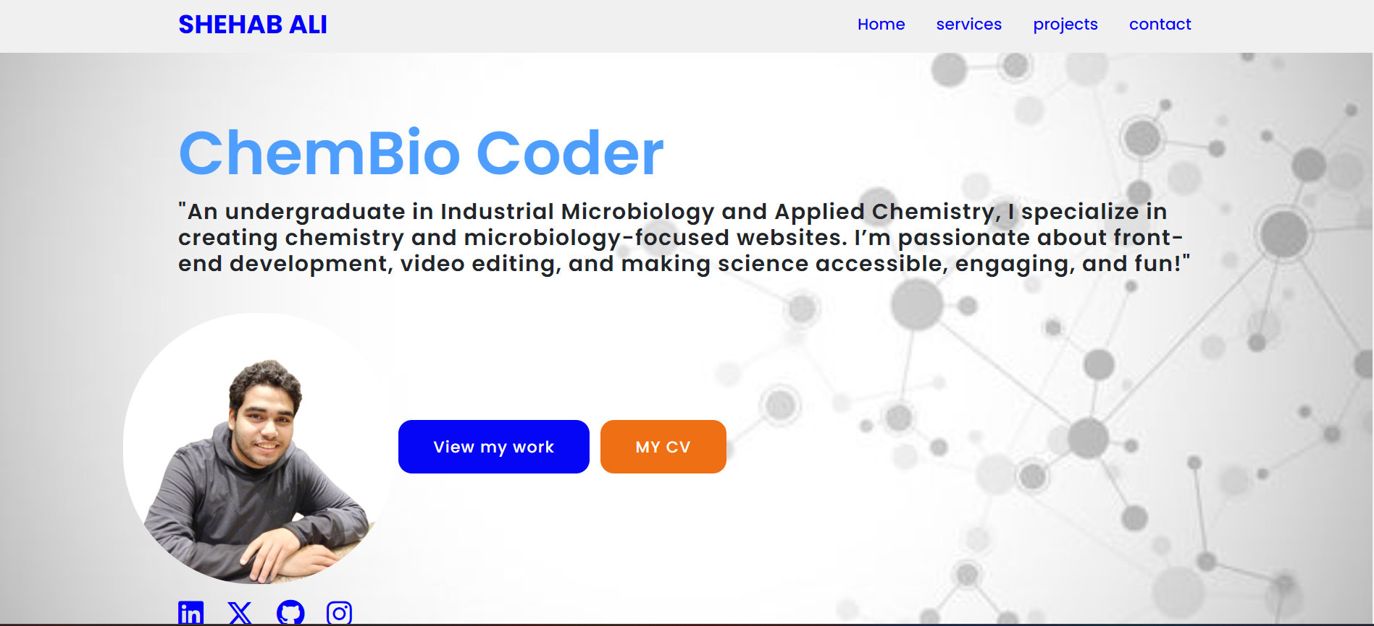

**1- Shehab Ali**

**2- ESLAM HOSSAM**

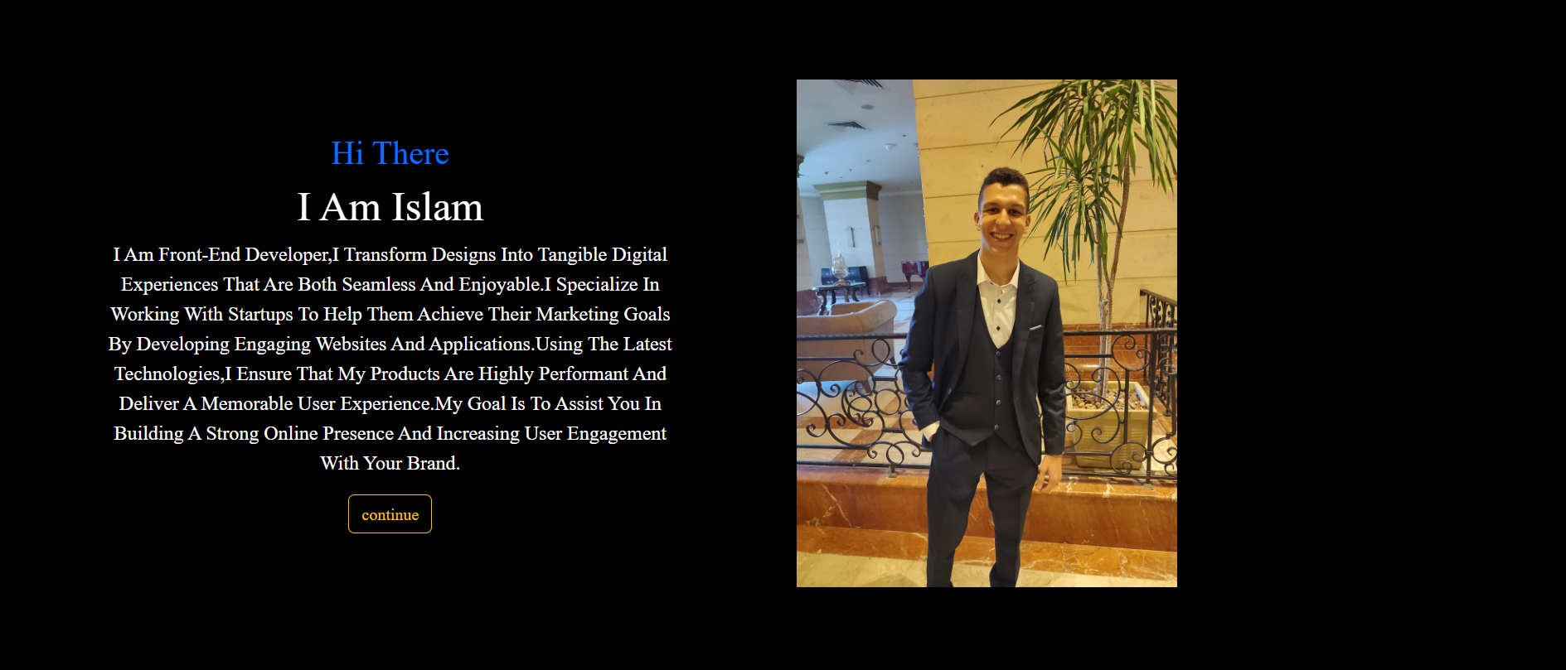

**3- AMAR AYMAN** 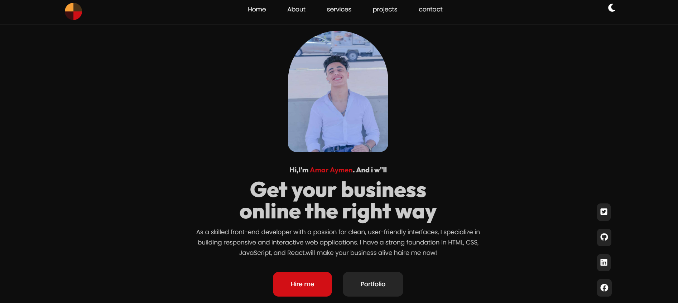

**4- HESHAM SHABKA**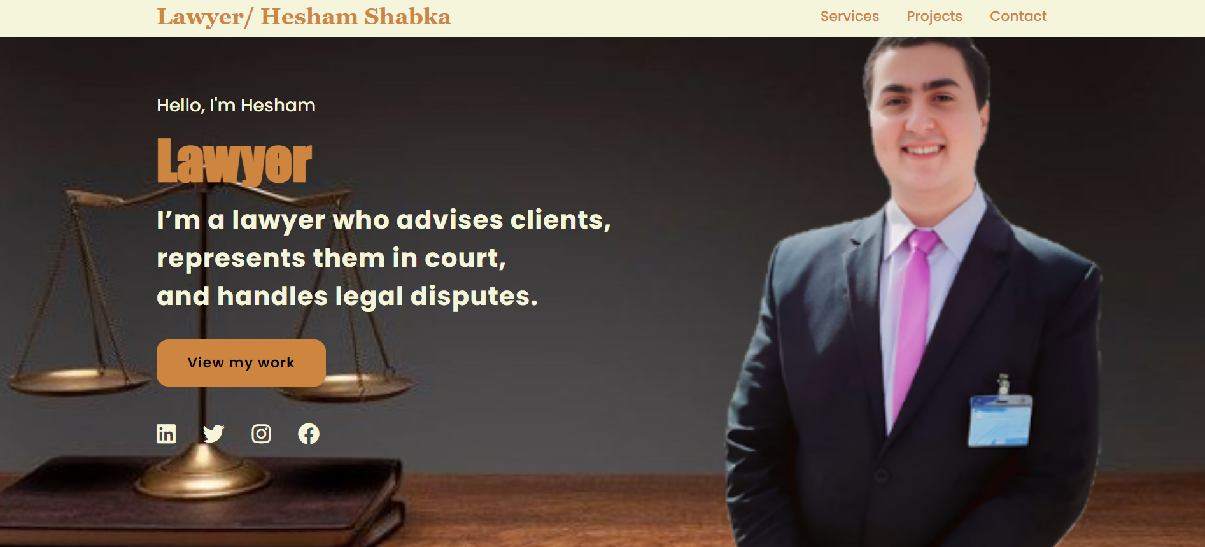

**Conclusion**

Our website is designed to be i**ntuitive and user-friendly**, making it easy for you to navigate and explore our offerings. Whether you are interested in our chemistry/microbiology expertise, legal services, web design, or career coaching, this platform provides a streamlined way to learn about our work, view our portfolio, and reach out for assistance. If you need help or have any questions, don’t hesitate to use the contact form to get in touch with us.

**OUR GROUP BY YAT AS TRAINING CENTER FOR TECHNICAL “YAT213_ALX1_SWD3_S1e”**

**& I-CAREER FOR COACHING**

**& SYE Corporate for business English**